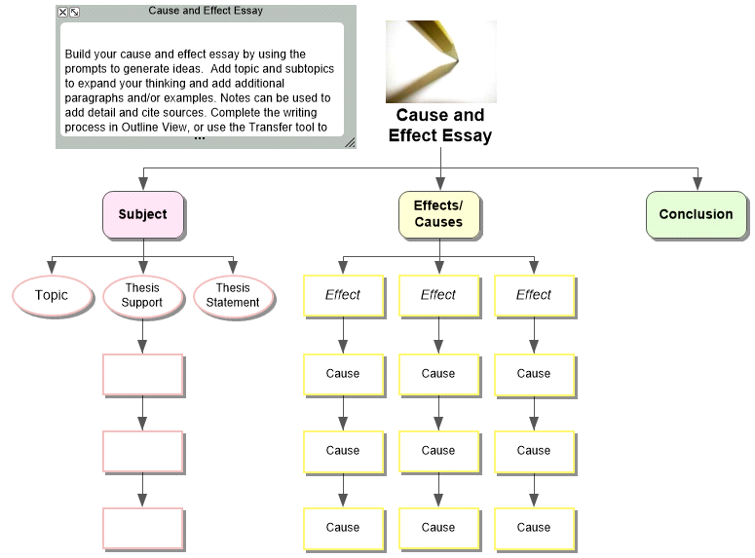

I. Globalizing Production
A. Redistribution and Reorganization
Choose a topic for which you are able to make a cause (reason) and effect (result) connection.
B. Thesis Statement
The production of goods and services in the United States, Western Europe, and Japan have been redistributed and reorganized.
Write a general statement that shows the relationships between the cause and the effect.
C. Thesis Support
Which 3 points will explain or prove your thesis statement?
1. Between 1945 and 1970, redistribution of production promoted economic development in U.S.;
2. After 1970, redistribution of production came at U.S. expense; a process called deindustrialization, losing jobs to firms based in Western Europe and Japan;
3. In 1980s and 1990s, U.S. firms reorganized production, largely through mergers and new technology, making them more competitive with Western Europe and Japan.
II. Effects/Causes
Redistributing Work
Break down the larger topic into smaller pieces, supporting each effect with causes.
A. Effect [i.e., consequence]
By 1973, the U.S. produced only 21.9 percent of world’s manufactured goods, down from approximately 57 percent in 1948; A significant share of manufacturing and agricultural shifted from U.S. to Western Europe (WE) and Japan. By mid-1970s, Western Europe self-sufficient in food production, less consumption of food grown in U.S. (Schaeffer: 2).
What is an effect of the problem, event or issue?
1. Cause –Military aid to Western Europe and Japan through Marshall Plan; $2 trillion from 1950–1970; rebuild infrastructure after World War II devastation; Money into these countries had a number of unintended consequences (Schaeffer: 3).
What causes explain why the effect happened?
2. Cause—U.S. government allowed nations to impose high tariffs on imported U.S. goods; $78 billion U.S. firms invested in WE during 1950s and 1960s created jobs and goods there Schaeffer: 3).
3. Cause—Bretton Woods agreement, fixed exchange rates, allowed WE and Japan to compete as equals with U.S., even though they weren’t as competitive;
B. REDISTRIBUTION AND DE-INDUSTRIALIZATION, 1970-1979
Effect—In 1971- U.S. posed first trade deficit since 1893, $2.3 billion
1. Cause—Demand for manufactured goods declined after U.S. withdrawal from Vietnam and slowing arms and space race with Soviets;
2. Cause—OPEC oil embargo forced higher energy prices and poor Soviet grain harvests increased food costs (Schaeffer: 6).
3. Cause—Recovery and growth of WE and Japan increased supplies from these regions;
Some important factors resulting in redistribution of production during 1970s
- Decline of U.S. steel industry—U.S. polices kept steel prices low, lowering profit rates and making it difficult for steel industries to innovate; Steel production fell from 130 million tons in 1970 to 88 million tons in 1985;
- Decline of U.S. auto industry—In 1960s, Volkswagen Beetle introduced into U.S.; by 1970, accounted for 15 percent of U.S. market; Superseded by Japan auto manufactures; Why?? Purchased 4 million Japanese cars in 1970, but twelve million in 1980 (Schaeffer: 8). U.S. automakers slow to innovate, trouble with unions, and moved production overseas; By 1980, 37 percent production moved abroad;
- Aircraft—In 1965, WE competed with U.S. by organizing AIRBUS, used govt. aid to build aircraft; Plane saved fuel ( fewer engines needed) and operating costs (fewer pilots needed); In 1999, Airbus received more orders than Boeing!!
C. REORGANIZING PRODUCTION, 1980-2000
Effect—Reorganization helped U.S. industries regain markets in 1990s, when industries in WE and Japan slumped; For U.S. workers, reorganization resulted in job loss (i.e., downsizing) and lowered incomes, while their stock portfolios increased;
1. Cause—U.S. President Ronald Reagan passed legislation to reform Social Security, Individual Retirement Accounts (tax-free) more widely available, increasing from $30 billion 1980 to $370 billion in 1990; money then invested in stock market; Flood of investment from wealthy U.S. investors and foreigners: IRAs, 401ks, wealthy individuals, and foreign investors;
2. Cause—Reagan administration cut corporate taxes, and stopped enforcing anti-trust laws, which was used to prevent mergers and monopolizing tendencies of capitalism;
3. Cause—Between 1982 and 1987, Dow Jones rose from 777 to 2,722; But in 1987, Dow fell 508 pts, Dow remained strong because workers couldn’t withdraw without penalty!!
4. Cause—Rising stock prices put pressure on fund managers to produce profits for investors, resulting in strategies that negatively affected U.S. workers: corporate mergers and new technologies to increase production and profits; In 1980, mergers worth $33 billion; Between 1981 and 1996, firms arranged mergers worth $2 trillion.
5. Cause-- New Technologies—Reorganizing of service-sector firms; In 1995, experts expected half of all banks to close---losing 2.8 million jobs; By 1998, eight hundred largest U.S. firms employed only 17 percent of workforce, down from approximately 26 percent in 1978;
6. Cause --Union Decline- Today percentage in unions only 9.4 percent, same number during Great Depression.
III. Conclusion
How will you sum-up the relationship between the causes and effects presented?

